Kickstarter Insights

# 3 conclusions based on the data set

## Subcategory

### Plays have the highest count of Kickstarter

### Most popular subcats with 100% successful Kickstarter campaigns:  Classical Music, Electronic Music, Hardware, Nonfiction, Pop, Tabletop games

## Category

### Theater has the highest count of successful Kickstarter, but Music has the highest % of successful Kickstarters

## Date

### May, June and July are the most popular months to run a Kickstarter

# Limitations of data set

74% of the observations are from the US, skewing the overall results by category and subcategory.

# Other possible tables/graphs to create

Number of Kickstarters by country

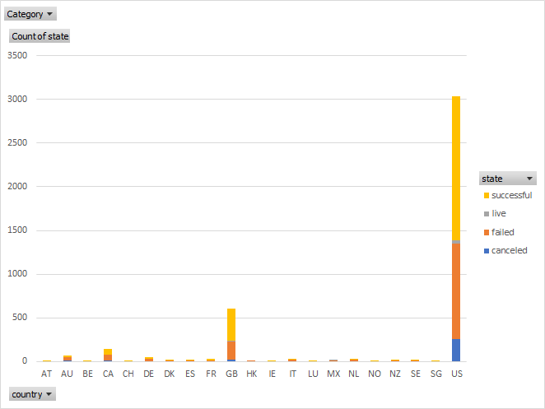

Subcategory: stacked chart by country

US

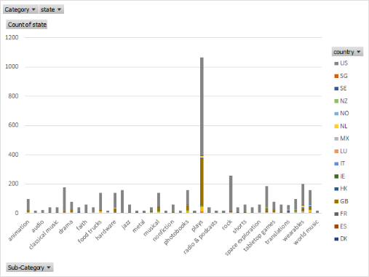

Germany

